User Design Interface

The user interface (UI) of BatEstateExplorer plays a crucial role in connecting users to the platform’s key functionalities. Crafted with a focus on
simplicity, accessibility, and user convenience, the UI ensures that both buyers and sellers (property owners/agents) can easily navigate and interact with the system. In a platform that facilitates property searches, listings, inquiries, and communication, the interface is essential for offering a smooth, efficient, and pleasant user experience. With a clean and intuitive layout, BatEstateExplorer aims to make property exploration hassle-free, allowing users to quickly search for properties, submit inquiries, and manage listings with minimal effort. The system’s responsive design ensures compatibility across various devices, providing a consistent experience whether accessed on a desktop, tablet, or mobile device. The UI is built to reduce cognitive load, promote engagement, and facilitate seamless transactions. As a result, BatEstateExplorer delivers an effective property inquiry service that meets the needs of its users in Batangas.
In Figure 11, the user interface of login form for administrator is displayed. The admin must enter their corresponding email address or phone number in Email or Phone Number Textbox (1), password must be entered in the Password Textbox (2), the Eye Icon Toggle (3) is necessary to hide password. In case the admin forgot their password, the Forgot Password Hyperlink (4) is used to reset it and can set another one. Once all necessary information is fulfilled, admin can enter Login Button (5) to enter the system.



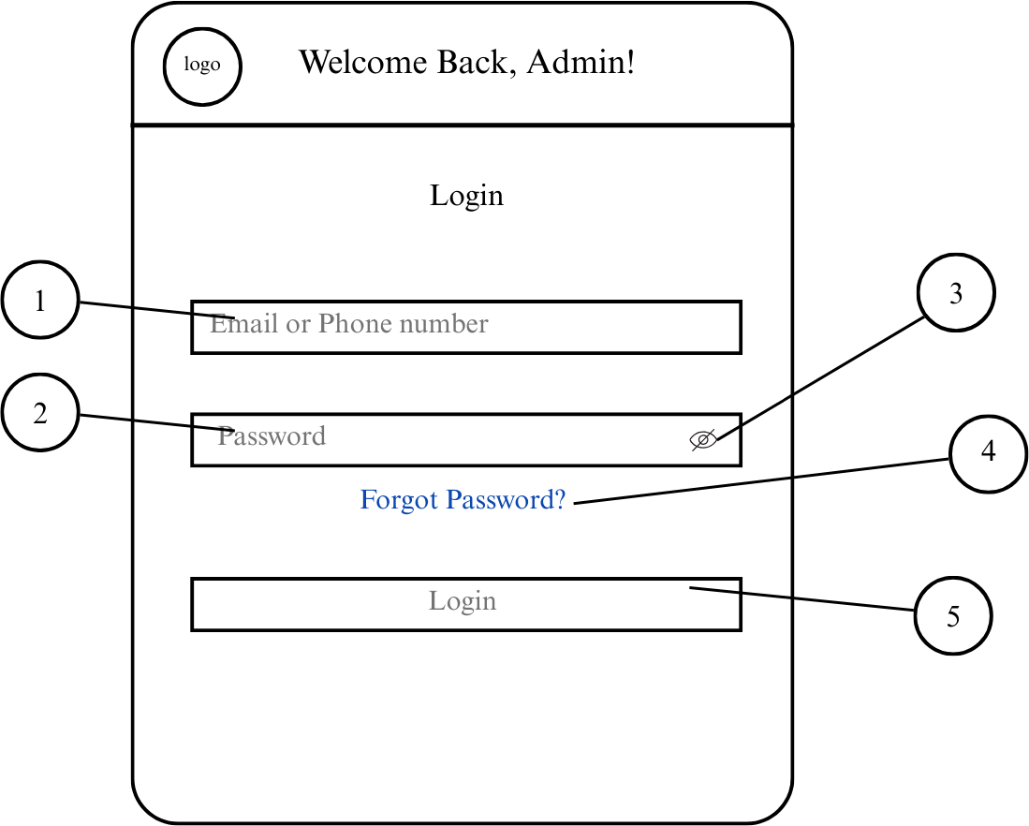

- Email or Phone Number Textbox

- Password Textbox
- Eye Icon Toggle

- Forgot Password Hyperlink

- Login Button

Figure 11. Login Interface (for Admin)

The interface of Admin Dashboard consists of Dashboard Button (1) to view Admin’s Dashboard, Manage Accounts Dropdown (2) that consists of Sub-Admins Button (3), Agents Button (4), Property Owners Button (5), and Clients Button (6) to manage users accounts. Property Listings (7) to manage property listing of



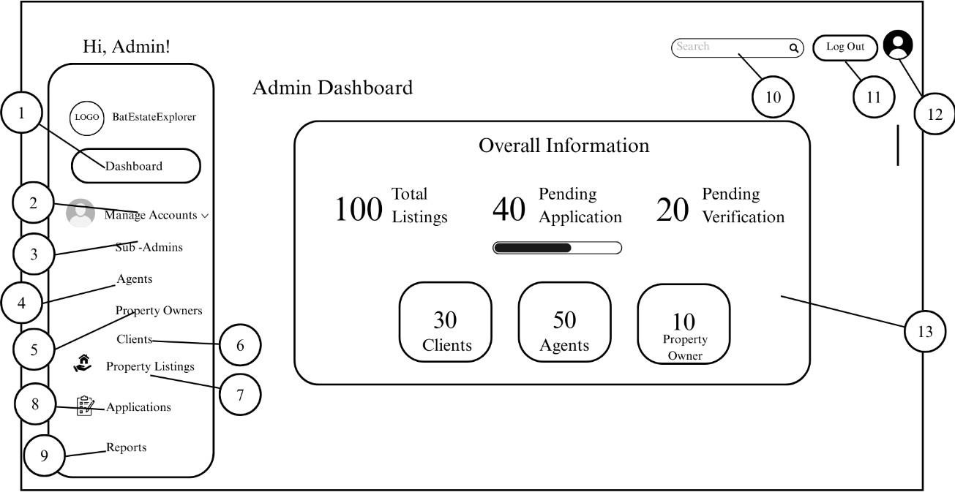

property owners and real estate agents, Applications Button (8) to manage application forms of applicants, Reports Button (9) to view daily reports of users. Search Bar (10) to find users. Logout Button (11) to exit the platform, Admin’s Profile Button (12) to view and edit profile, Overall Information Section (13) to view all information about the system.

- Dashboard Button
- Manage Accounts Dropdown

- Sub-Admins Button
- Agents Button

- Property Owners Button

- Clients Button




- Property Listings Button

- Applications Button
- Reports Button
- Search Bat

- Logout Button

- Admin’s Profile Button

- Overall Information Section

Figure 12. Admin’s Dashboard Interface




In figure 14, The administrator manages agents’ account. By clicking Sort by Dropdown (1) admin can sort information, View Details Button (2) to view more details, Message Button (3) to message agent, Remove Account (4) to remove the account from the platform.
- Sort By Dropdown

- View Details Button

- Message Button

- Remove Account Button



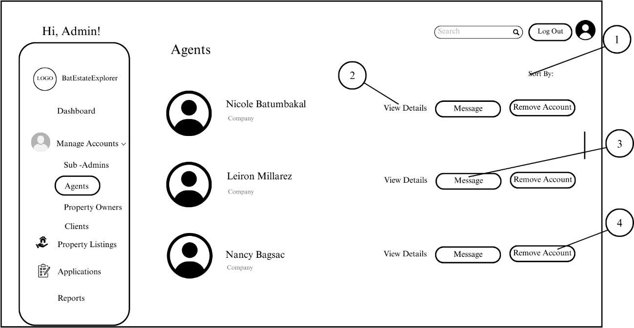

Figure 14. Manage Account (Agents) Interface

In figure 15, The administrator manages Direct Agent’s account. By clicking Sort by Dropdown (1) admin can sort information, View Details Button
(2) to view more details, Message Button (3) to message property owner, Remove Account (4) to remove the account from the platform.
- Sort By Dropdown

- View Details Button

- Message Button

- Remove Account Button



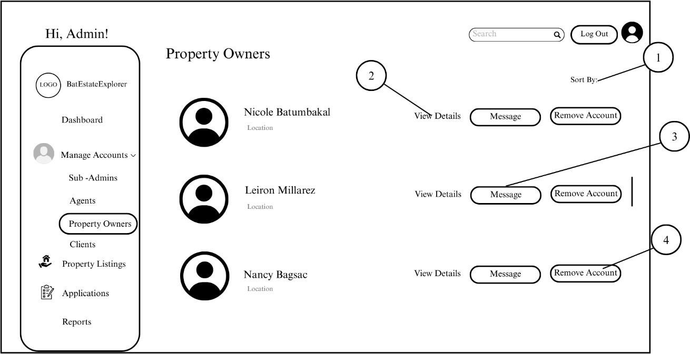

Figure 15. Manage Account (Direct Agents) Interface

In figure 16, The administrator manages Associate Agent’s account. By clicking Sort by Dropdown (1) admin can sort information, View Profile Button (2) to view profile of the client, Message Button (3) to message client, Remove Account (4) to remove the account from the platform.
- Sort By Dropdown

- View Profile Button

- Message Button
- Remove Account Button



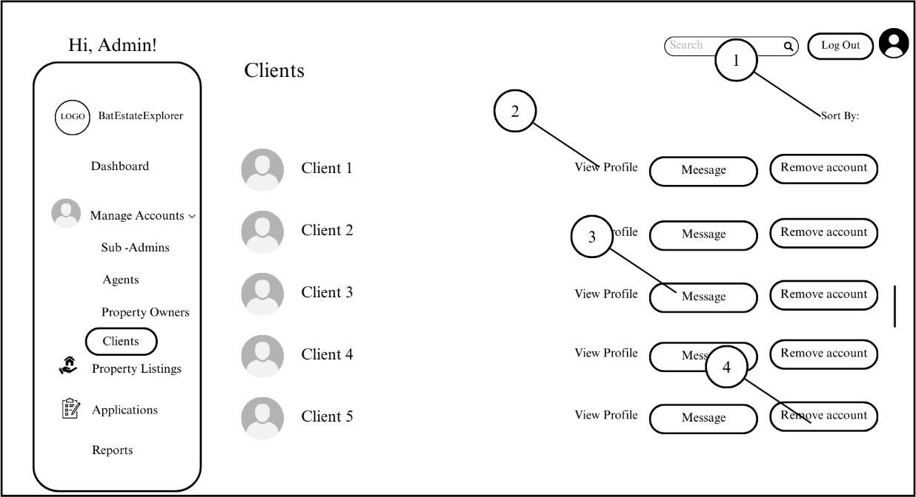

Figure 16. Manage Account (Associate Agents) Interface

In figure 17, The administrator manages Property Listings. It consists of Property Owners Section (1) to view property listings details from property owners with property’s name, type, price, date uploaded. Real Estate Agents Section (2), Sort by Dropdown (3) to sort information, View Post Button (4) to view post, View Property Document Button (5) to review submitted documents, Remove Post Button
(6) to remove post.

- Property Owners Section
- Real Estate Agents Section

- Sort By Dropdown

- View Post Button

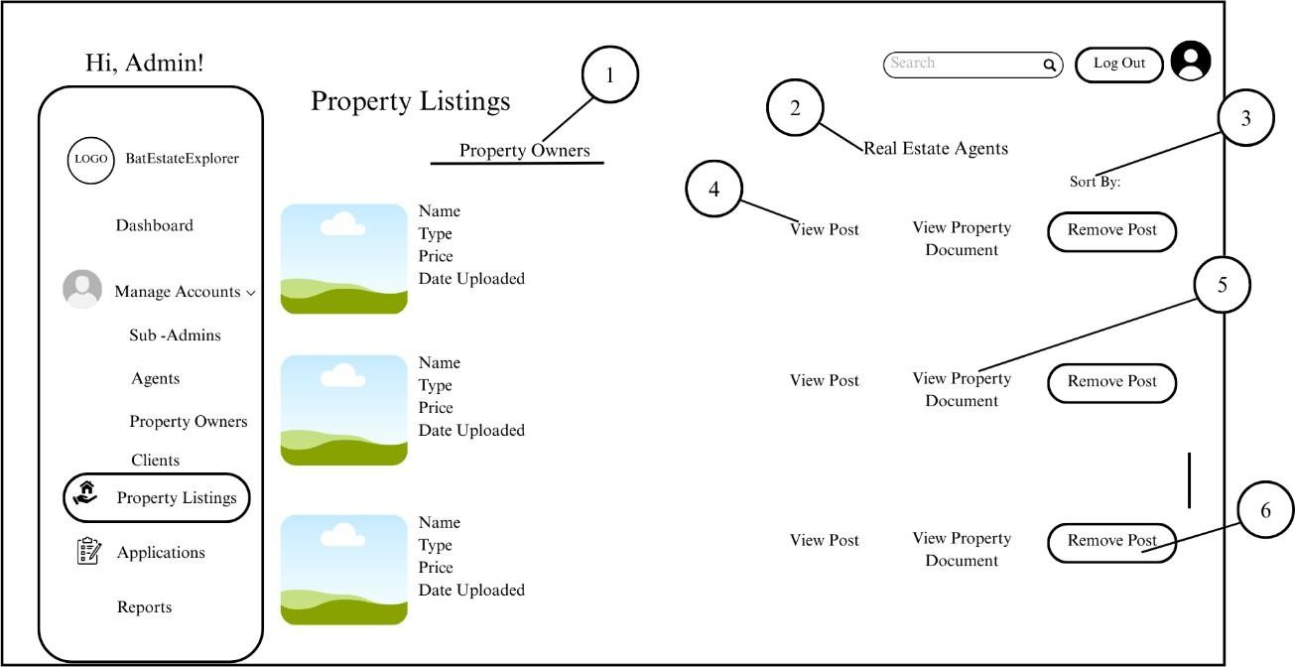



- View Property Document Button

- Remove Post Button

Figure 17. Manage Property Listings Interface

Figure 18 illustrates the managing interface of applications. It consists of View Application Form Button (1) to review application submitted by a user, Accept Button (2) to approve application and Reject Button (3) to decline application.
- Application Form Button

- Accept Button
- Reject Button



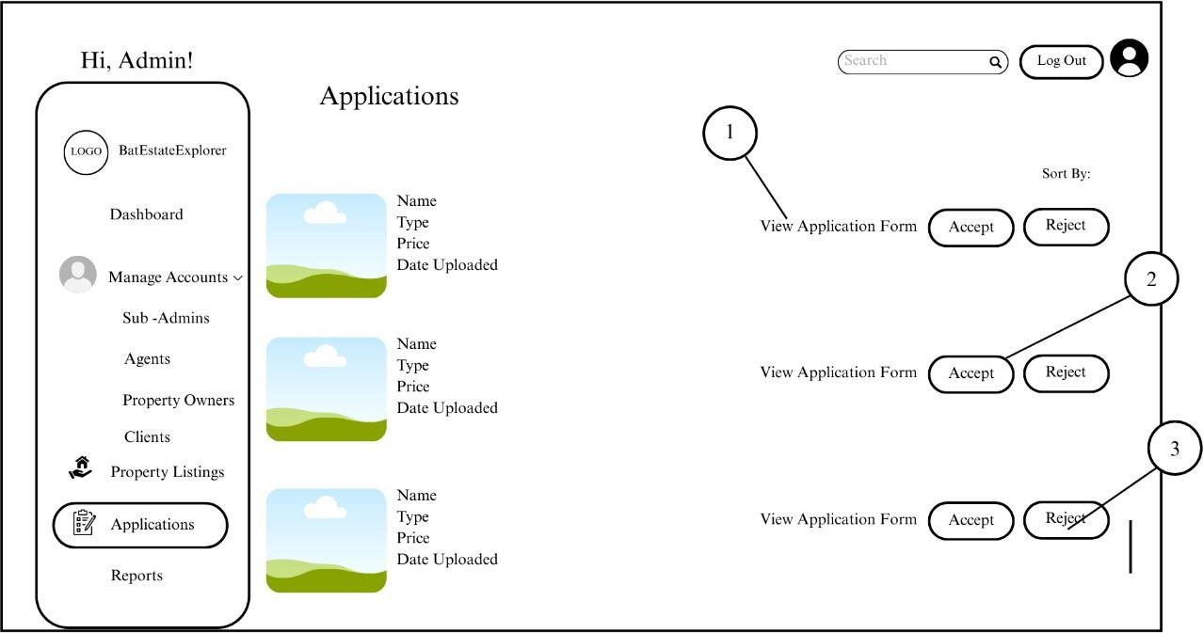

Figure 18. Manage Application Interface

Figure 19 illustrates the managing interface of reports. It consists of Property Owners Section (1), Real Estate Agents Section (2), Client Section (3), View Report Button (4) and Remove Post Button (5).
- Property Owners Section

- Real Estate Agents Section
- Client Section

- View Report Button

- Remove Post Button



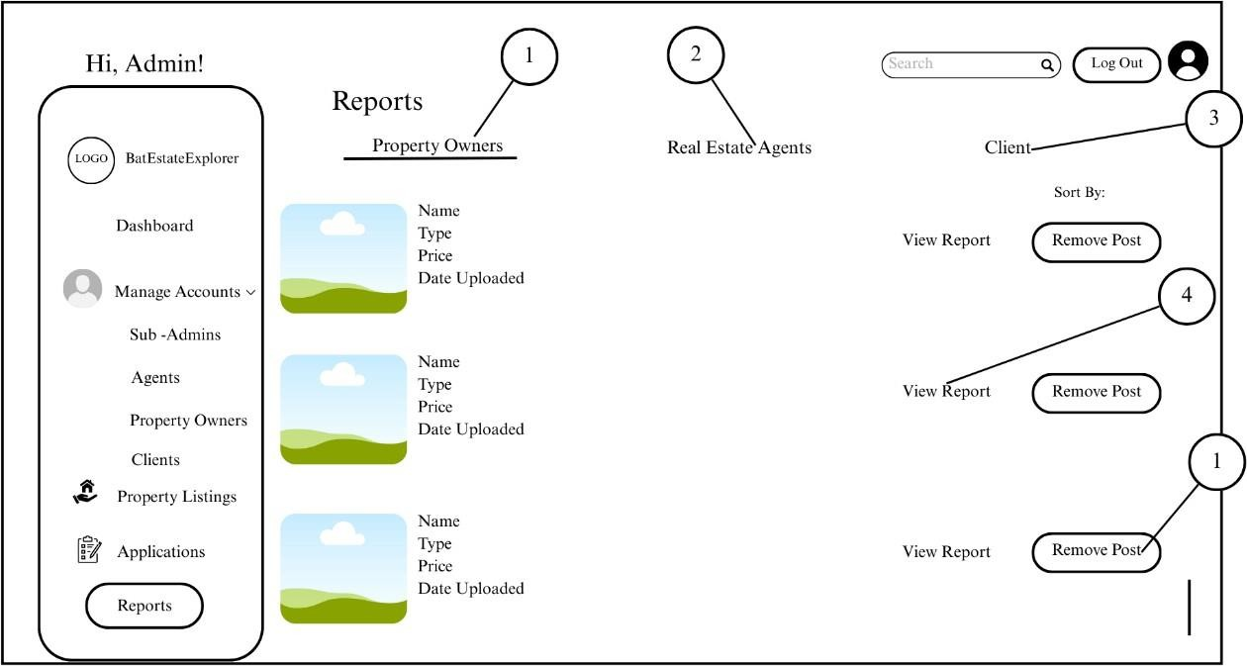

Figure 19. Manage Reports Interface

Figure 20 is the Sub-Admins’ Dashboard Interface. It consists of Dashboard Button (1) for easy navigation, Manage Accounts Dropdown (2) that has Agents Button (3) to manage Agents’ Account, Clients Button (4) to view client’s information, Property Listings Button (5) to manage property listings, Performance Button (6) to review agents’ performances, Search Bar (7) to find users. Log Out Button (8) to exit the platform, Profile Button (9) to view and update profile, and Overall Information Section (10) to monitor updates.
- Dashboard Button
- Manage Account Dropdown
- Agents Button



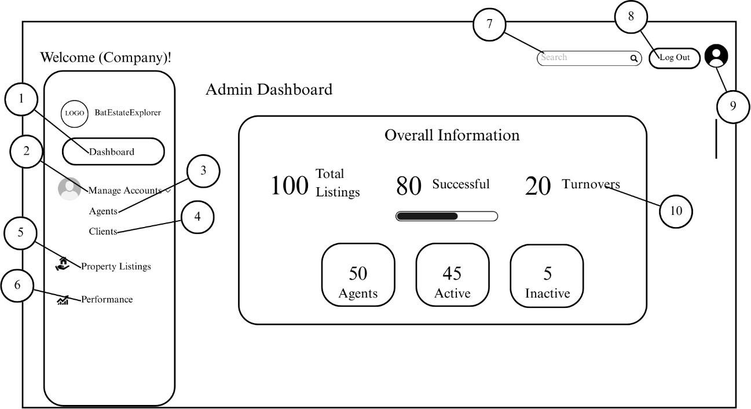

- Clients Button

- Property Listings Button
- Performance Button
- Search Bar Button

- Log Out Button

- Profile Button

- Overall Information Section Button

Figure 20. Sub-Admins’ Dashboard Interface

In figure 21, The sub administrator manages agents’ account. By clicking

Add Account Button (1) sub-admin can register new agent, View Details Button (2)



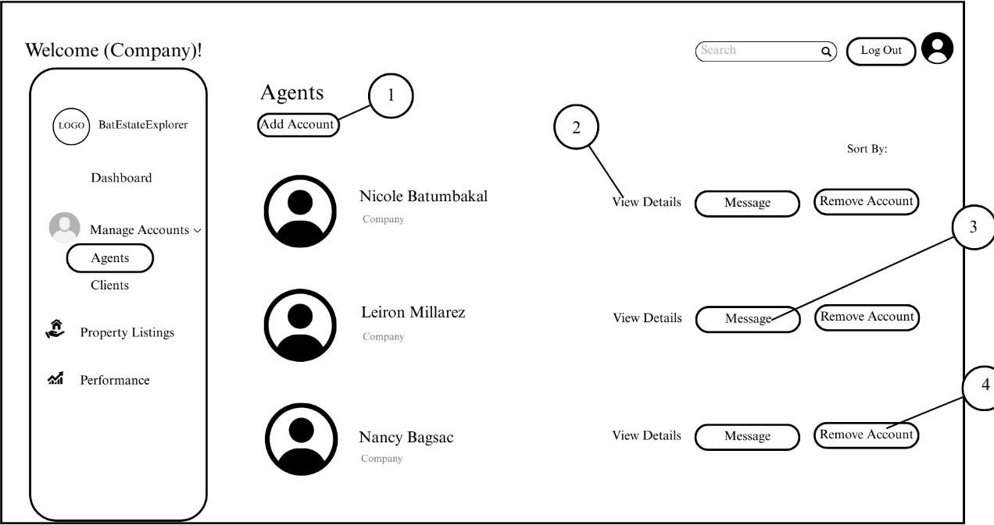

to view more details, Message Button (3) to message agent, Remove Account (4) to remove the account from the platform.
- Add Account Button

- View Details Button

- Message Button
- Remove Account Button

Figure 21. Manage Account (Agents) Interface

Figure 22 illustrates the sub-admin viewing of client’s information. It consists of Search Bar (1) to find users. Sort By Dropdown (2) to sort information. View Details Button (3) to view clients’ information, and Message Button (4) to message the client.



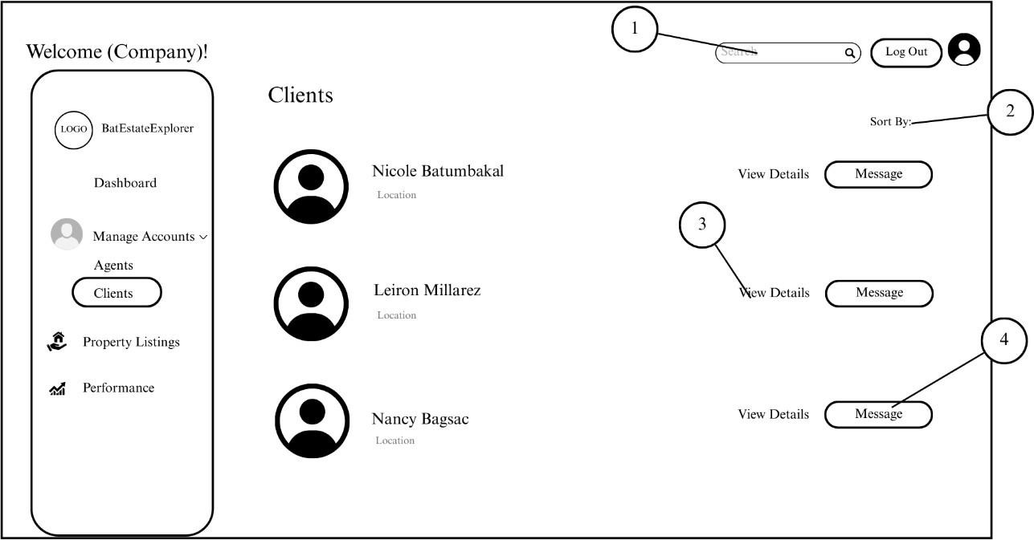

- Search Bar

- Sort By Dropdown

- View Details Button

- Message Button

Figure 22. View of Clients’ Information Interface

Figure 23 illustrates the sub-admins’ view of property listings. It consists of Sort by Dropdown (1) to sort information. View Post Button (2) to view details, View Status Button (3) to monitor availability status, and Remove Post Button (4).
- Sort By Dropdown



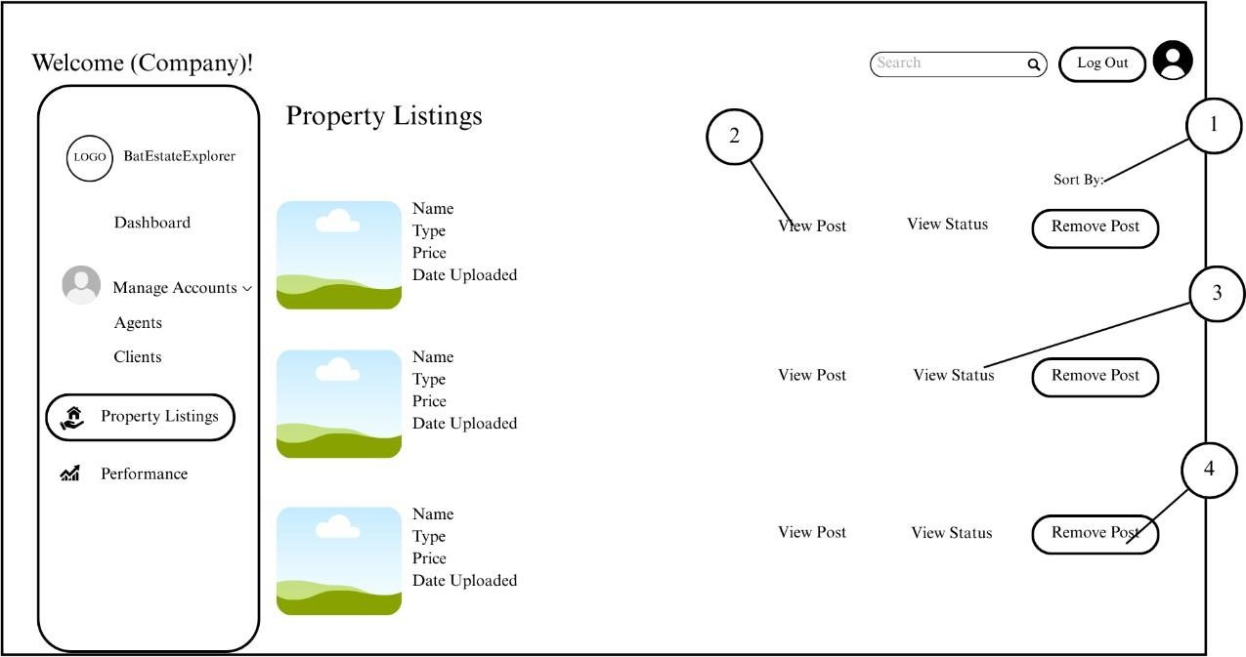

- View Post Button

- View Status Button

- Remove Post Button

Figure 23. Property Listings Interface

Figure 24 illustrates the Performance section where sub-admin can monitor the performance of their agents’ data in Graph (1) together with active and inactive agents, most selling property and top performing agent.
- Graph



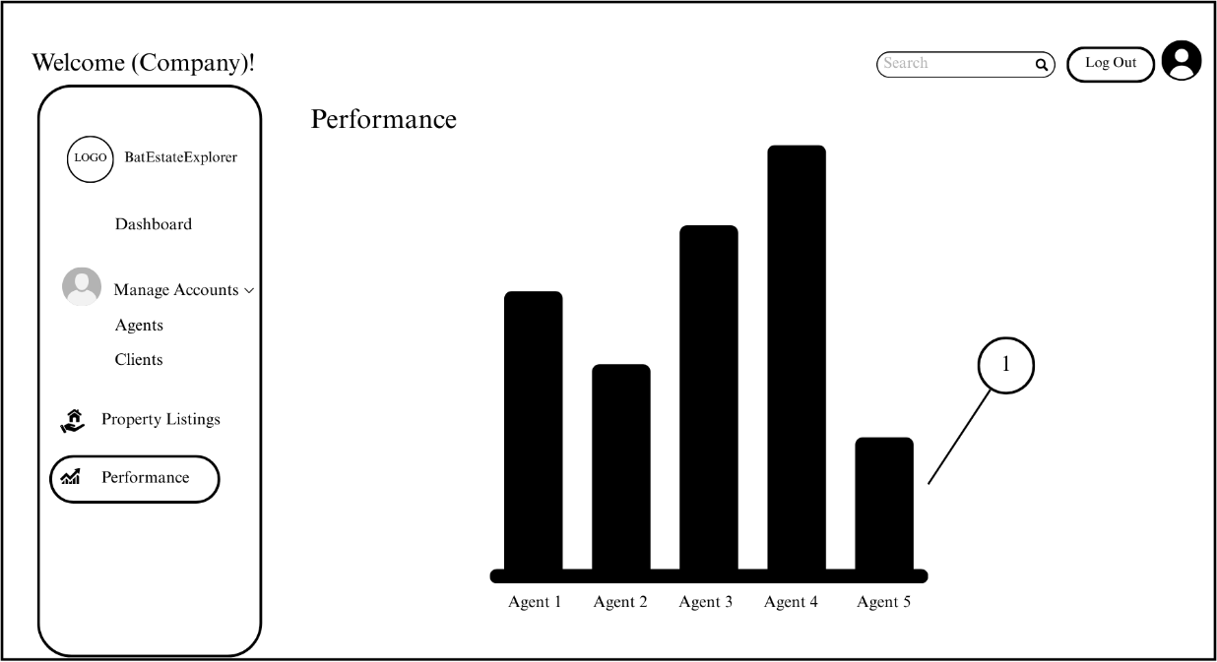

Figure 24. Performance Interface

Figure 25 illustrate the registration form for Direct agents. It consists of First Name Textbox (1), Last Name Textbox (2), Email Textbox (3), Password Textbox (4), Eye Icon Toggle (5), Confirm Password Textbox (6), Register Button (7), and Cancel Button (8).
- First Name Textbox

- Last Name Textbox

- Email Textbox

- Password Textbox



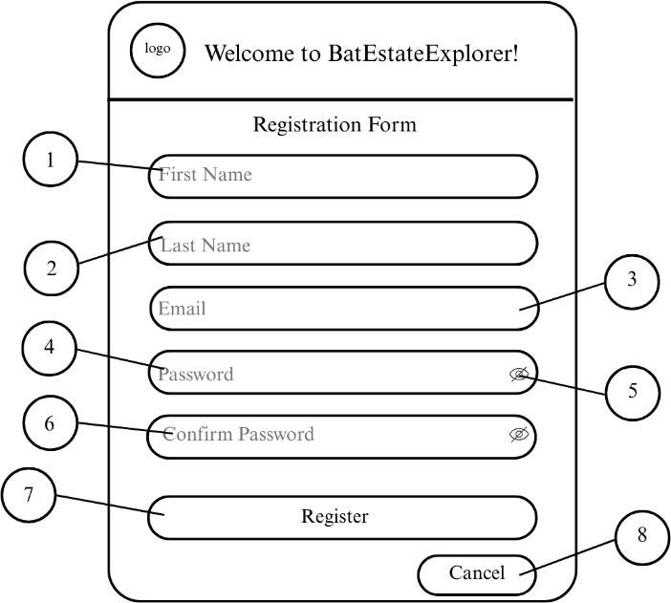

- Eye Icon Toggle

- Confirm Password Textbox

- Register Button

- Cancel Button

Figure 25. Registration Form for Direct Agent

Figure 26 illustrate the login form of Direct agents. It consists of Email or Phone Number Textbox (1), Password Textbox (2), Eye Icon Toggle (3), Forgot Password Hyperlink (4) and Login Button (5).
- Email or Phone Number Textbox



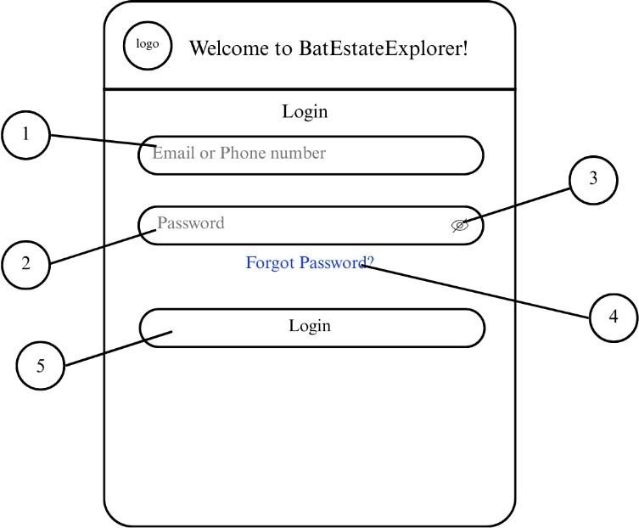

- Password Textbox

- Eye Icon Toggle

- Forgot Password Hyperlink

- Login Button

Figure 26 Login Interface (Direct Agents)

Once the Direct Agents logged in, the next interface is the homepage. It consists of Account Dropdown (1) that has Edit Profile Button (2), Delete Account Button (3), Inbox Button (4) for messages, Manage Posts Button (5), Log Out Button (6) to exit the platform, Search Bar (7) to find users, Profile Icon Button (8) to view and update profile.



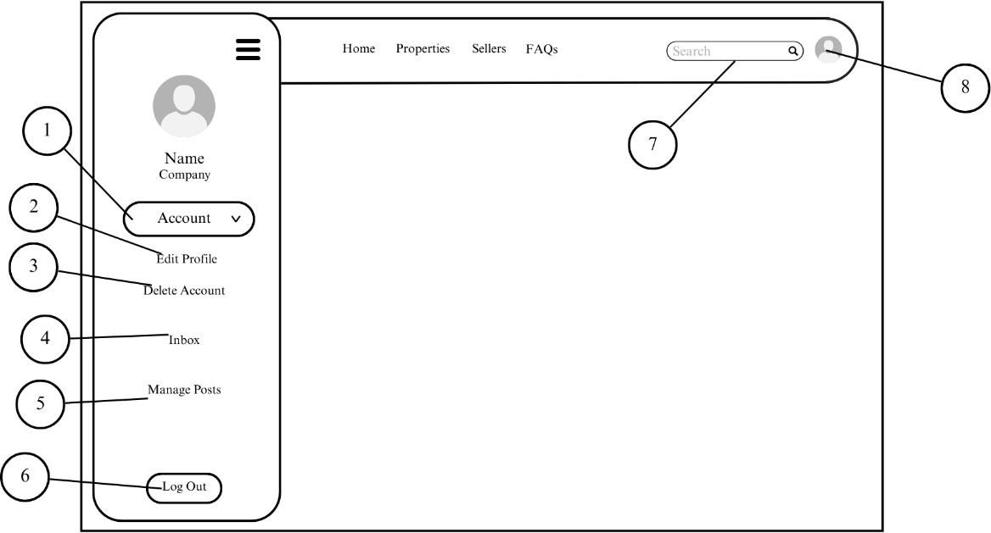

- Account Dropdown

- Edit Profile Button

- Delete Account Button

- Inbox Button

- Manage Posts Button

- Log Out Button

- Search Bar

- Profile Icon Button

Figure 27. Homepage Interface (Real Estate Agent)



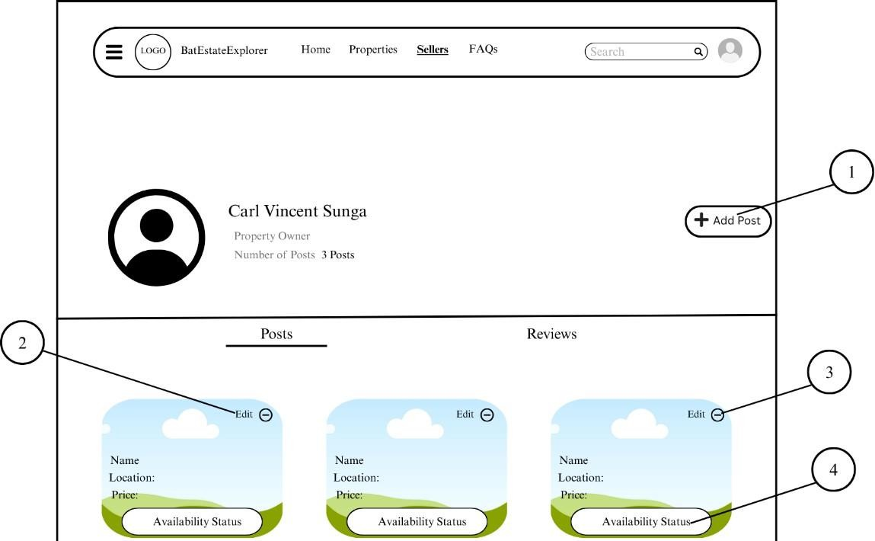

Figure 28 shows the User Profile of the Direct Agent. The Agent can upload new listings through Add Post Button (1), The Agent can also edit existing posts through Edit Post Button (2) and of course can delete own posts by clicking Delete Post Button (3). Availability Status Button (4) to update availability status of the listing.

- Add Post Button
- Edit Post Button

- Delete Post Button
- Availability Status Button

Figure 28. User Profile (Direct Agent) Interface



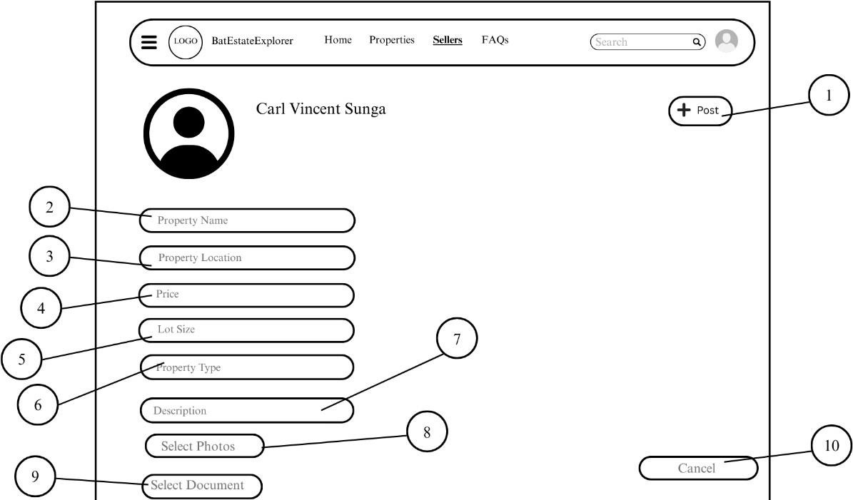

Figure 29 shows the details when a seller is uploading a new property. It consists of Post Button (1) to post property, property details with Property Name Textbox (2), Property Location Textbox (3), Price Textbox (4), Lot Size Textbox (5), Property Type Textbox (6), Description Textbox (7), Select Photo Button (8) to select property image, Select Document Button (9) to select property’s document, and Cancel Button (10) to cancel upload.

- Post Button

- Property Name Textbox
- Property Location Textbox

- Price Textbox

- Lot Size Textbox



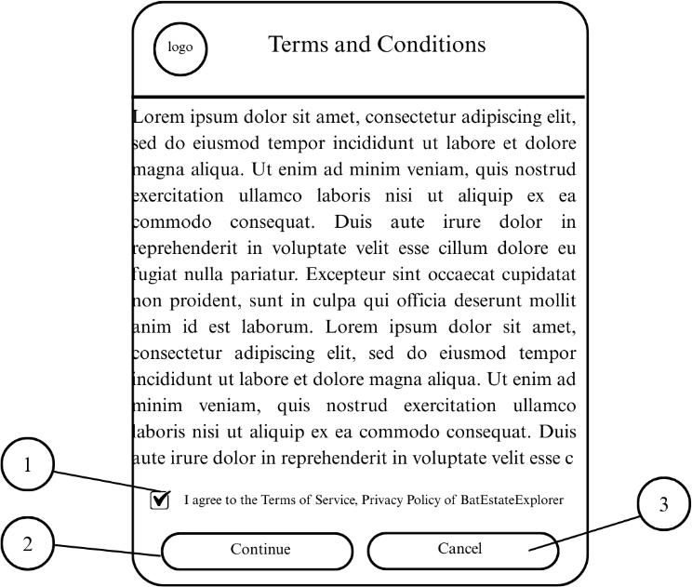

- Property Type Textbox

- Description Textbox
- Select Photos Button
- Select Document Button

- Cancel Button

Figure 29. Upload Post Interface

Figure 30 shows the pop message of Terms and Condition and Privacy Policy before submitting the property document. To inform the agents and property owners that it is for verification purposes only. It consists of Checkbox (1). Continue Button
(2) and Cancel Button (3).

- Checkbox



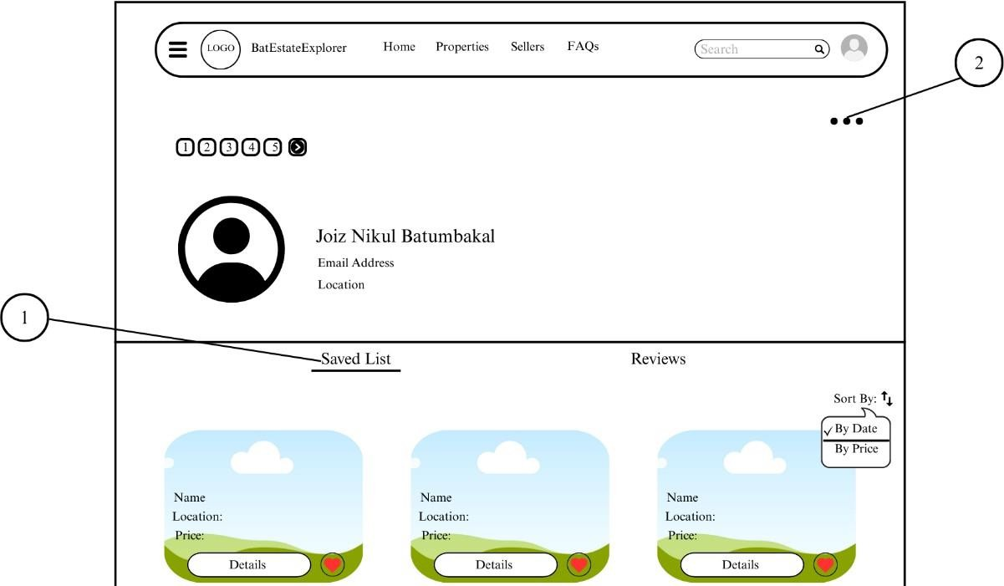

- Continue Button

- Cancel Button

Figure 30. Terms and Condition and Privacy Policy Interface

Figure 31 shows the User Profile of a User in perspective of the Seller. The seller can view the saved list of the client in the Saved List Section (1). The Option Button (2) is also present to have a conversation with the client.
- Saved List Section

- Option Button (to message)

Figure 31. User Profile (Client) Interface

In Figure 32, the user interface for login form for user (client/ buyer) is displayed. In order to authenticate onto the BatEstateExplorer, users must enter them



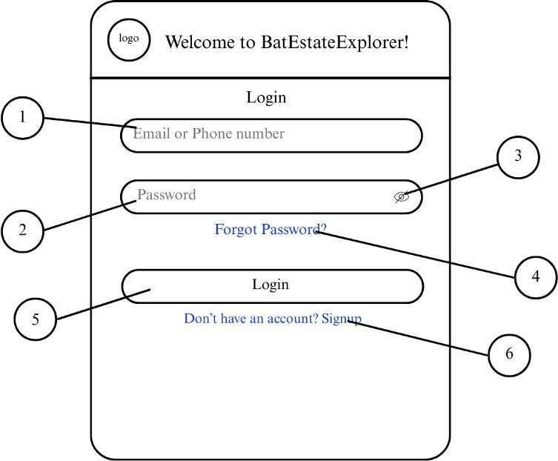

corresponding email address or phone number in the Email Textbox (1) on the login page. Password must enter in the Password Textbox (2), the Eye Icon Toggle (3) is necessary to hide password. In case the user forgot their password, the Forgot Password Hyperlink (4) can reset it and can set another one. Once all necessary information is fulfilled, users can enter Login Button (5) to enter the system, but if the user doesn’t have an account yet the user can click the Signup Hyperlink to create one.

- Email or Phone Number Textbox

- Password Textbox

- Eye Icon Toggle




- Forgot Password Hyperlink

- Login Button

- Signup Hyperlink

Figure 32. Login Interface for User (Client/Buyer)

In Figure 33, the user interface for signup form for user (client/buyer) is displayed. It is where users can create a new account if they don’t have yet. By clicking the First Name Textbox (1) and enter their first name, next its Last Name Textbox (2), next is personal email in Email Textbox (3), next is entering a desired password in Password Textbox (4), Eye Icon Toggle (5) is necessary in hiding the password while typing to avoid leaking, next is entering Confirm Password Textbox
(6) to confirm password if it’s matched to the previous password. By agreeing to the terms of service and privacy policy of the system one must check the Checkbox (7) and submitting it by clicking the Signup Button (8). If the user already has an account, they can click the Login Hyperlink (9).



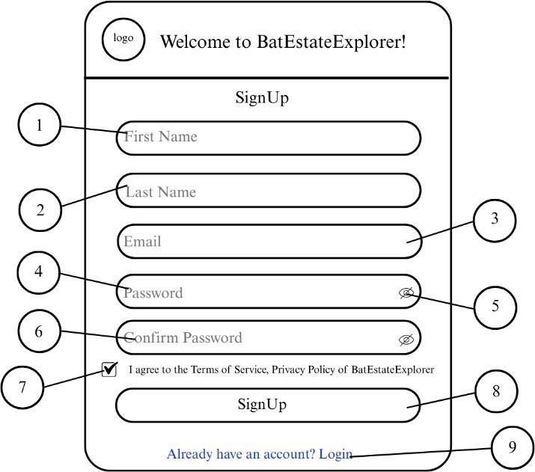

- First Name Textbox

- Last Name Textbox

- Email Textbox
- Password Textbox

- Eye Icon Toggle

- Confirm Password Textbox
- Checkbox

- Sign Up Button
- Login Hyperlink

Figure 33. Signup Interface for User (Client/Buyer)




Figure 34 is the user interface of the Homepage. It consists of Menu Bar (1) that opens the side navigation panel for other user options or settings, Home Button (2), to bring the page back to Home, Properties Button (3) to look up for a property by entering desired filter, Sellers Button (4) to search a seller (real estate agent/ property owner), a Frequently Asked Questions Button (5) to inquire when the broker is inactive, a Saved List Button (6) to save desired listing and for future preferences, a Location Dropdown (7) is one of a search filter that consists of municipalities, barangay and street, a Category Dropdown (8) that has a selection of whether to buy, to rent-to-own or both, Type Dropdown (9) to specify type of property desired by user, a Price Dropdown (10) to select price or can choose to enter desired amount, and a Search Button (11) to search property based on filtered preferences. Once the result is found the images together with Details Button (12) to show full details of the property, a Heart Button (13) to save desired property to Saved List and a Next Button (14) to show next property.



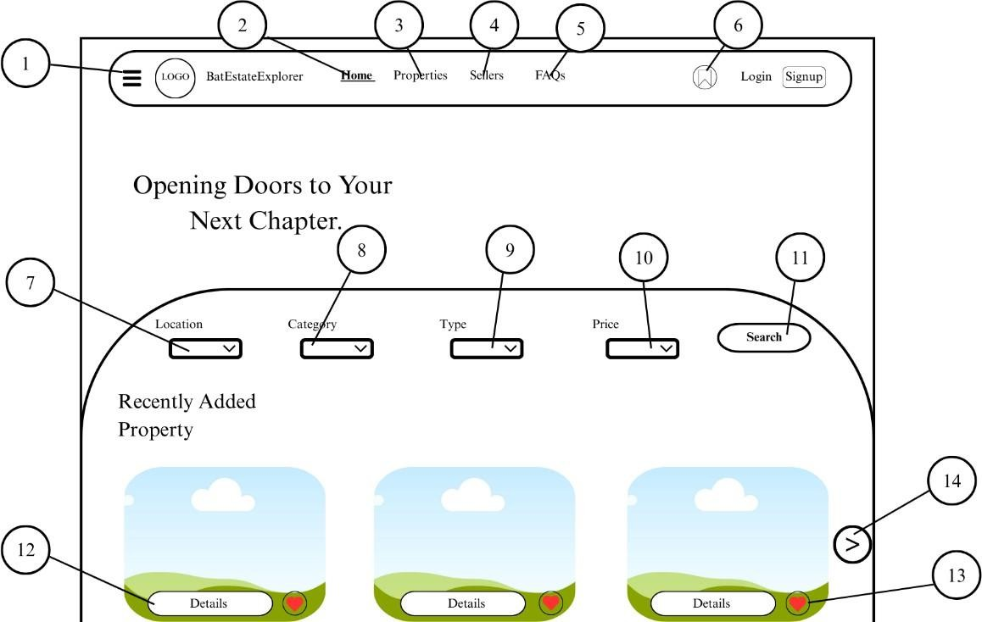

- Menu Bar

- Home Button

- Properties Button
- Sellers Button

- FAQs Button

- Saved List Button
- Location Dropdown

- Category Dropdown
- Type Dropdown

- Price Combo Box

- Search Button



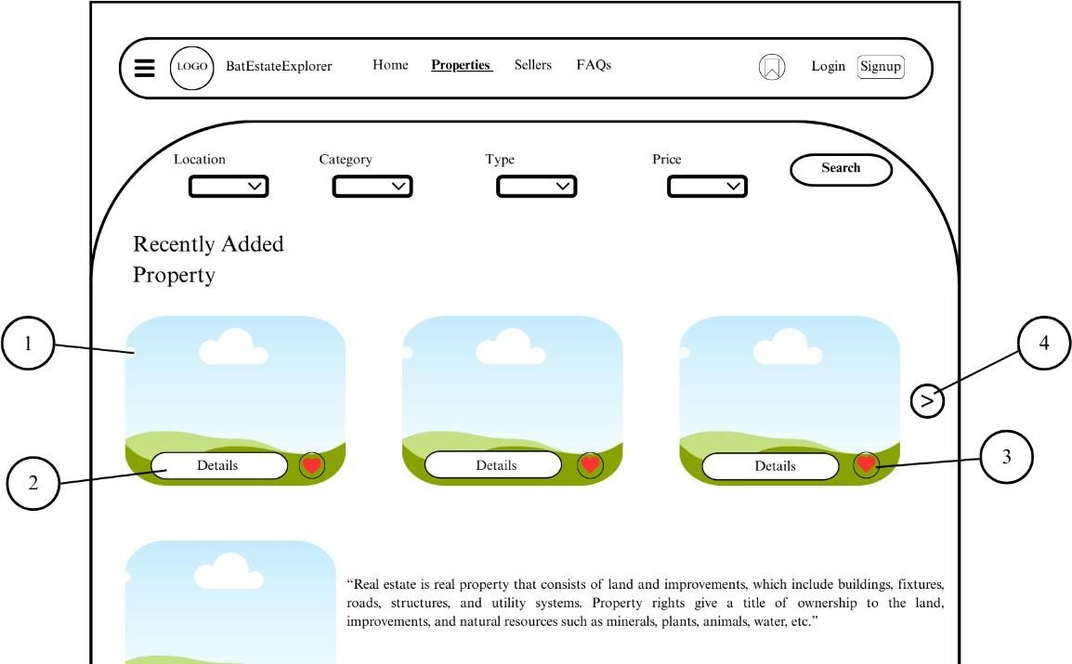

- Details Button

- Heart Button
- Next Button

Figure 34. Homepage Interface of BatEstateExplorer

Figure 35 shows the result when the user clicks the properties tab at the top of the website. Once it is entered it will show Recently Uploaded Property with a Property Image Box (1), with its details and can view full details if the user clicks the Details Button (2), and can save it through clicking the Heart Button (3) and can navigate through next property by clicking the Next Button (4).

- Property Image Box

- Details Button



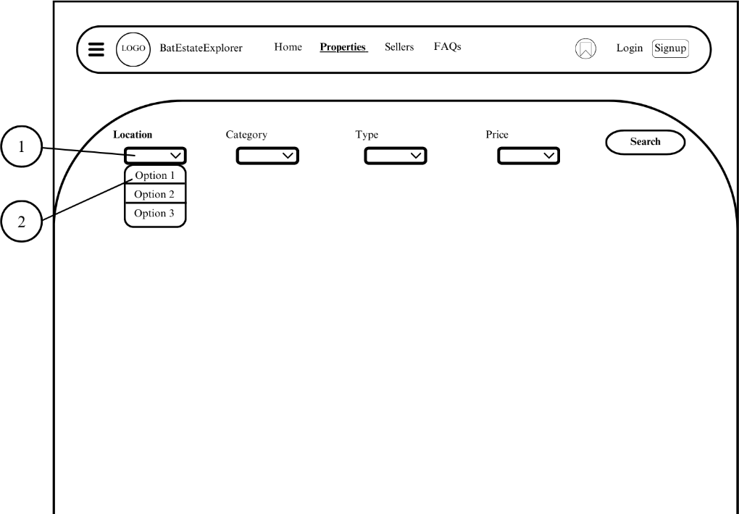

- Heart Button

- Next Button

Figure 35. Properties Tab Interface

Figure 36 shows a Location Filter. A Location Dropdown (1) is one of a search filter that consists of municipalities, barangay and street that shows in Dropdown Options (2).

- Location Dropdown

- Dropdown Options

- Figure

Figure 36. Location Selection Interface



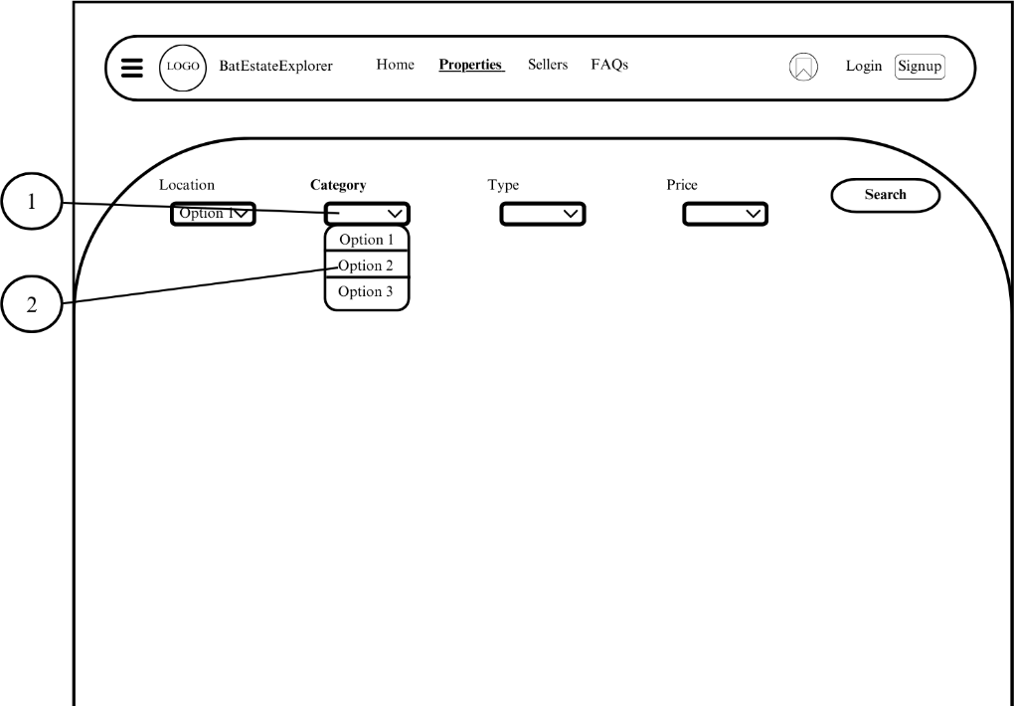

Figure 37 shows a Category Filter. A Category Dropdown (1) has an option whether to buy, rent-to-own or both, it shows in the Dropdown Options (2).

- Category Dropdown
- Dropdown Options

Figure 37. Category Selection Interface
Figure 38 shows a Type Selection Filter. A Type Dropdown (1) has an option to choose a type of property based on the user’s preference; the options are shown in Dropdown Options (2).
- Type Dropdown

- Dropdown Options



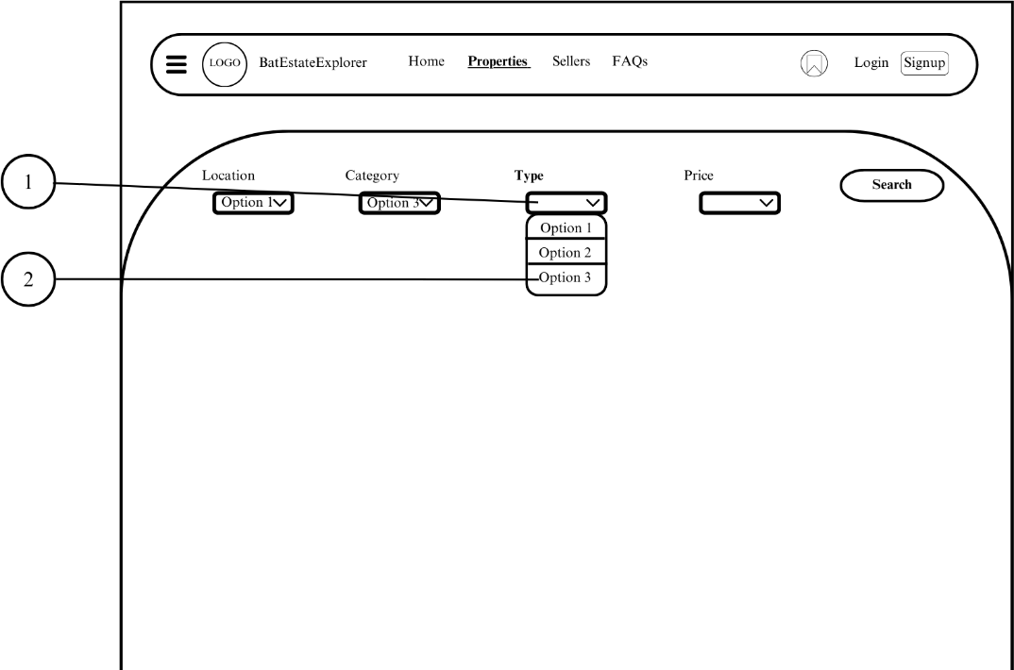
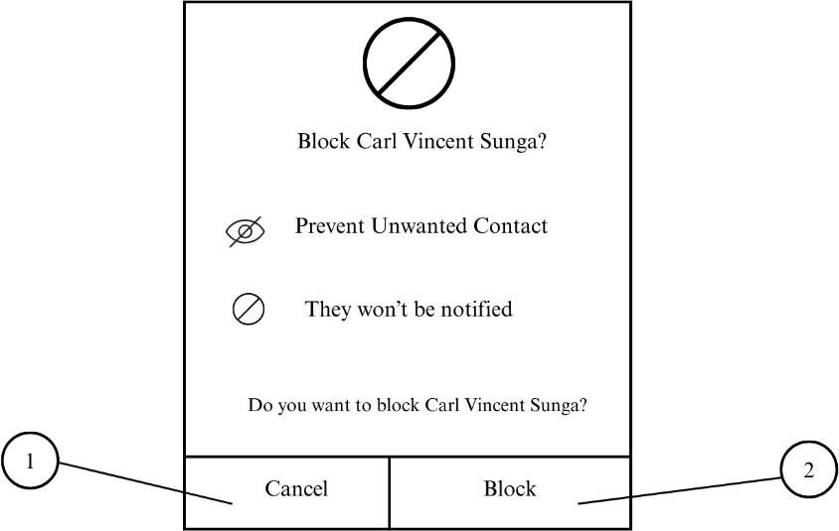

Figure 38. Type Selection Interface

Figure 39 shows a Price Combo (1) in which a user can enter any desired amount and can choose on the options shown in Dropdown Options (2).

- Price Combo Box



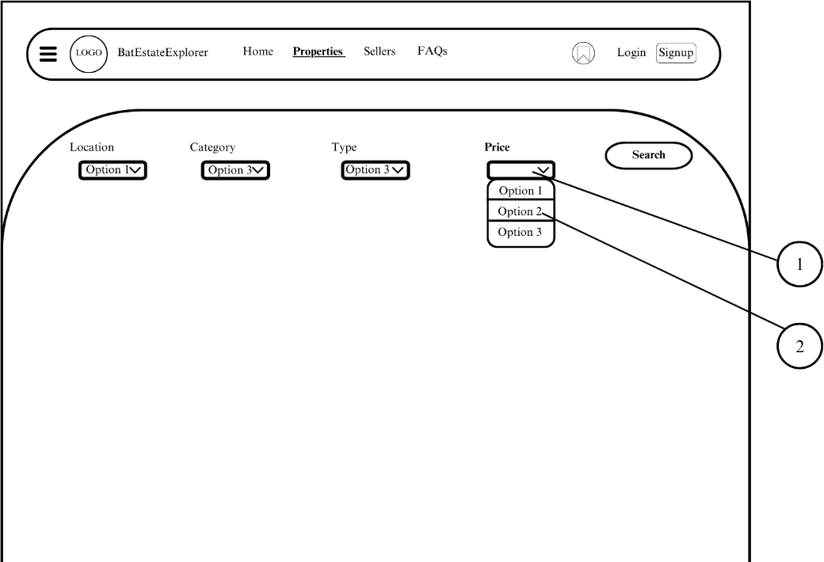

- Dropdown Options

Figure 39. Price Combo Box Interface
Figure 40 shows the Search Property Interface. Once the filter has applied, user can click the Search Button (1) and wait for the result to come out.

- Search Button

Figure 40. Search Property Interface

Figure 41 shows the result. It consists of Property Image Box (1), Details Text (2) of the searched property, Details Button (3) to access full details of the property, Heart Button (4) to save it and Next Button (5) to see the next property.
- Property Image Box
- Details Text



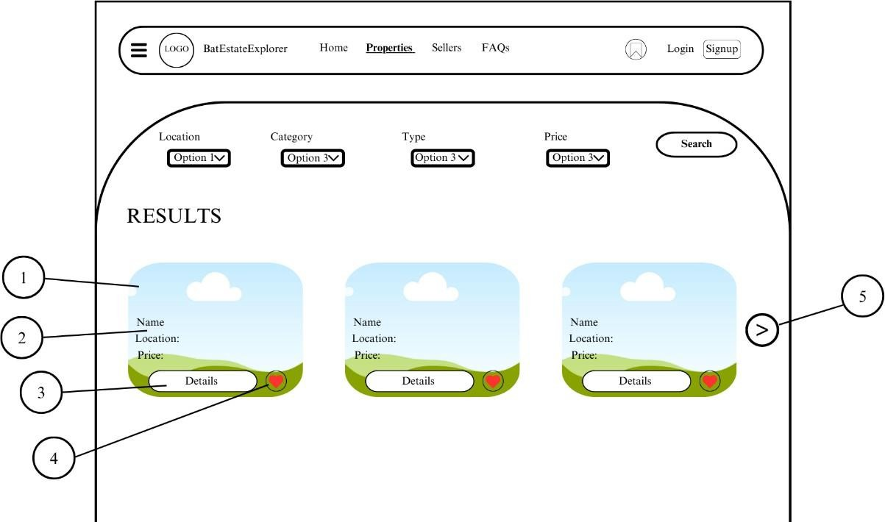

- Details Button

- Heart Button
- Next Button

Figure 41. Search Result Interface

Figure 42 shows the interface where the user clicks the Details Button, it will proceed to full display of property details including Inquire Now! Button (1) to start a conversation with the seller. (2) Heart Button to save the property, (2) Next Button to see the next property, Details Text (4) or the full details of the property and Description Text (5) used to describe the property to engage more users to inquire.
- Inquire Now! Button

- Heart Button



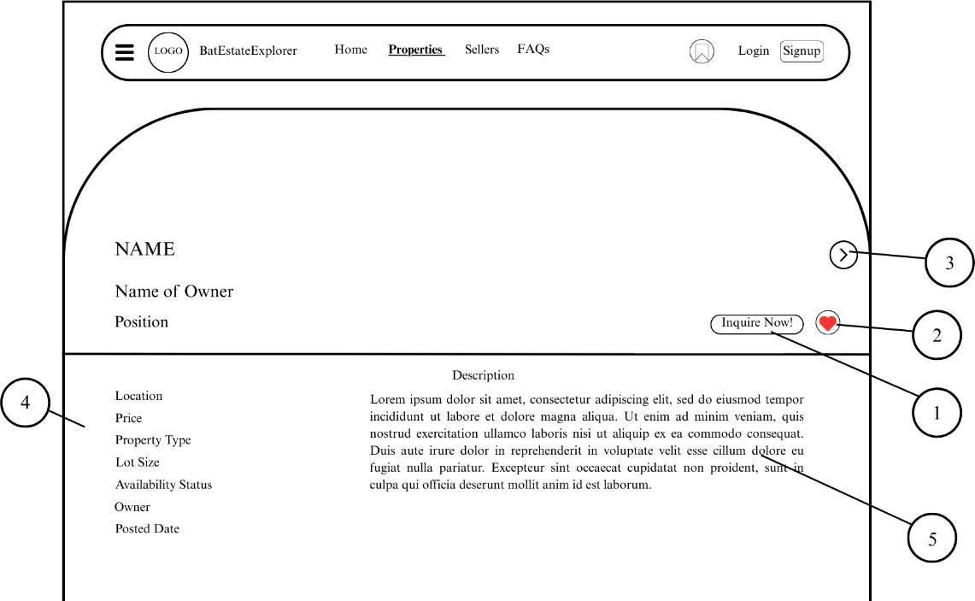

- Next Button

- Details Text
- Description Text

Figure 42. Full Details of Searched Property

Figure 43 shows the interface if the user proceeds to clink inquire now button. The interface now consists of Option Button (1) that includes view profile of seller, back to search property, block seller and rate. AI-Powered Chatbot (2) that is available in case the seller is inactive, an Add Attachment Button (3) at the bottom left to include photos, a Message Box (4) to enter a message and Send Button (5) to send the message to the seller.
- Option Button



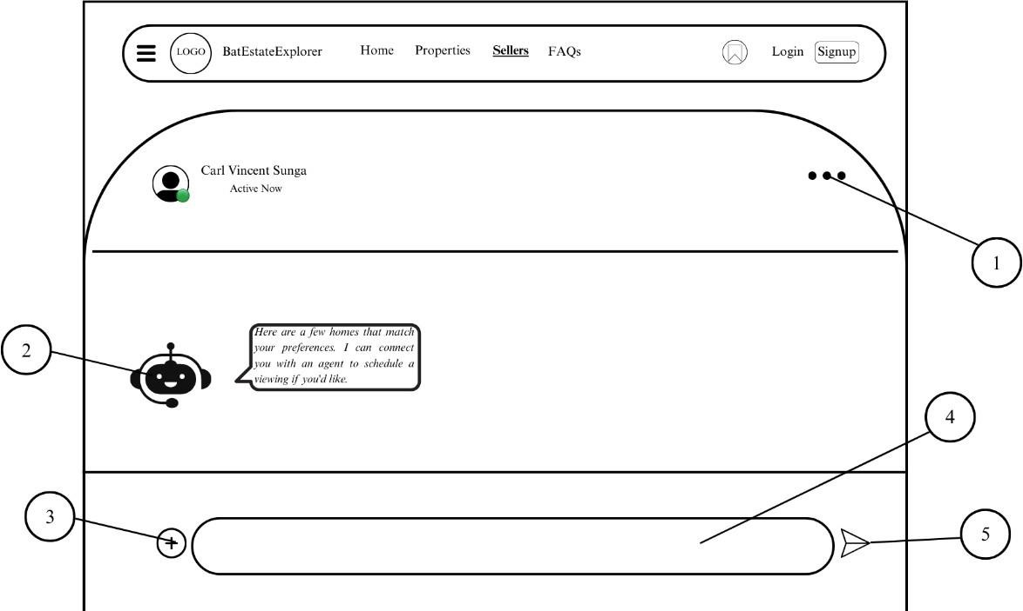

- AI-Powered Chatbot

- Add Attachment Button
- Message Box
- Send Button

Figure 43. Inquiry with Seller Interface

Figure 44 shows the options available in the Option Menu. It consists of View Profile Button (1) to see the seller’s profile, Back to Property Search Button (2) to bring back to property search, Block Seller Button (3) in case of suspicious or offensive behavior, Rate Seller Button (4) to provide feedback.
- View Profile Button
- Back To Property Search Button



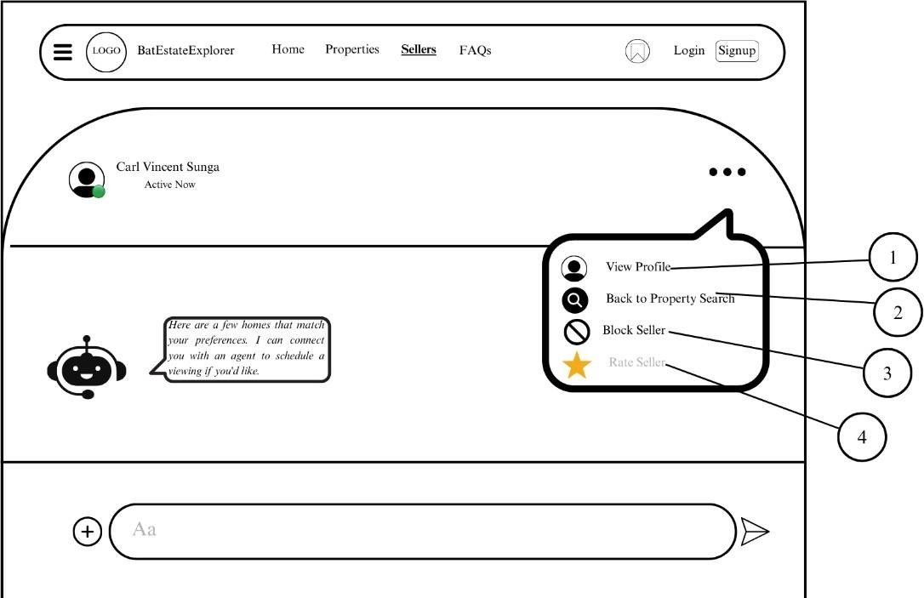

- Block Seller Button

- Rate Seller Button

Figure 44. Option Menu Interface

Figure 45 show the interface where a user clicks Sellers at the top of the page. It consists of Search Bar (1), Breadcrumbs (2), Real Estate Agents Section (3), Property Owners Section (4).
- Search Bar

- Breadcrumbs

- Real Estate Agents Section

- Property Owners Section



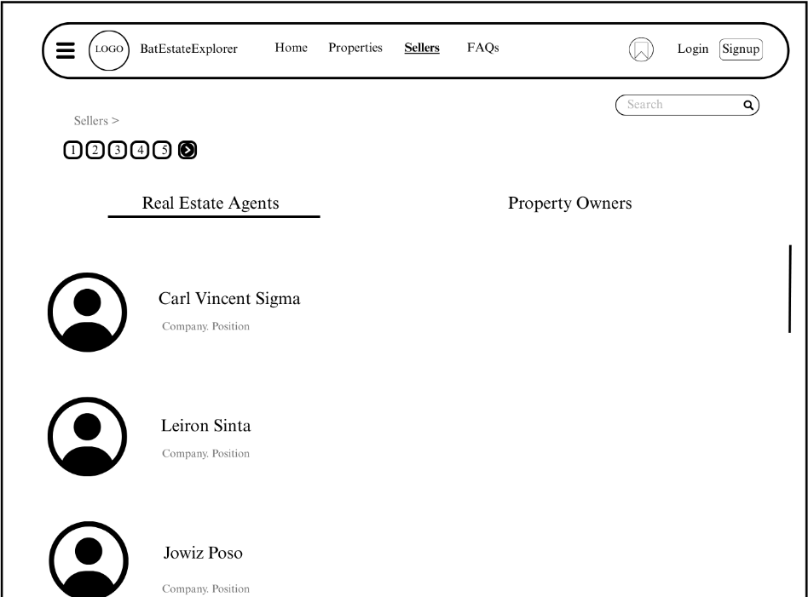

Figure 45. All Sellers Interface

Figure 46 illustrates the interface if the user chose to view Property Owners section. It consists of Breadcrumbs (1) or path, User Profile Button (2) and Details Texts (3).
- Breadcrumbs

- User Profile Button
- Details Texts



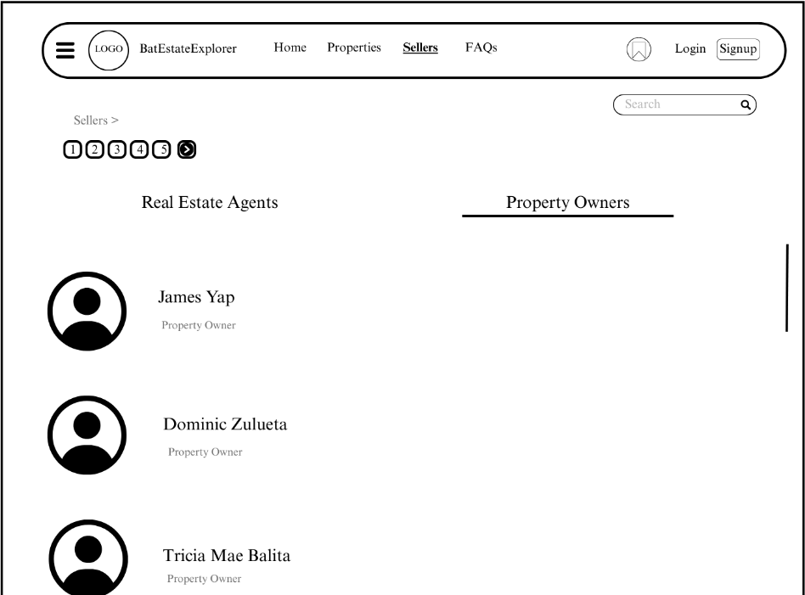

Figure 46. Sellers (Property Owners) Interface

Figure 47 shows the interface if the user chose to view the seller’s profile. It has a Next Seller Button (1), Agent’s Profile Picture (3), Posts Section Text (2) that has current posts of properties, Reviews Section Text (3) that shows reviews and feedback by other client and a Sort by Dropdown (5) to sort property lists and reviews depending on price or by date.
- Next Seller Button

- Agent’s Profile Picture
- Posts Section Text

- Reviews Section Text

- Sort By Dropdown



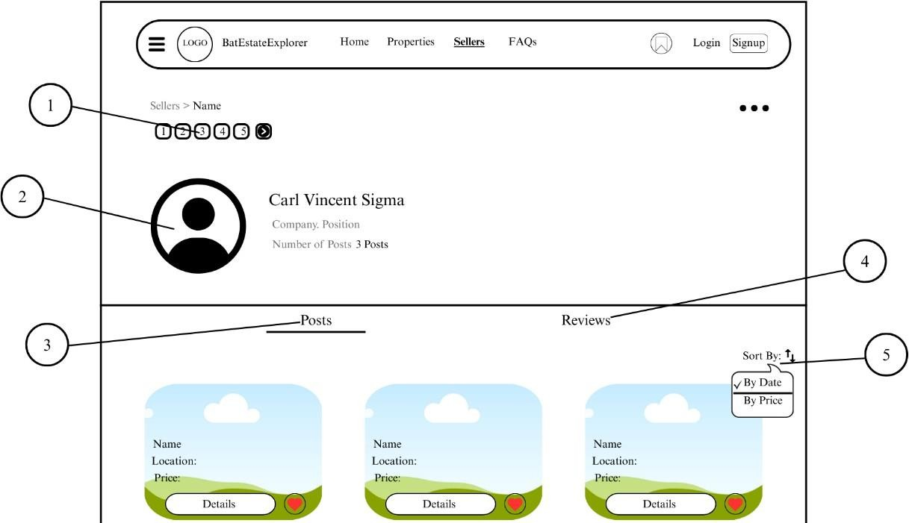
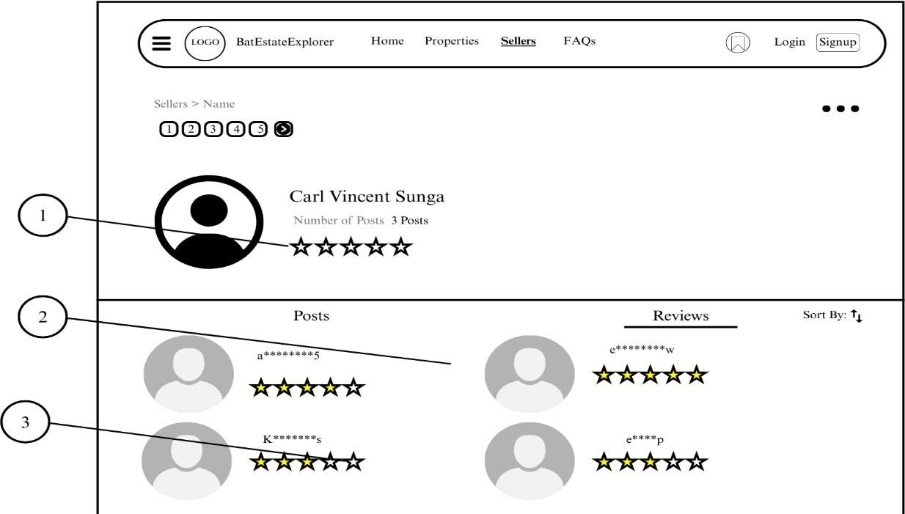

Figure 47. Seller’s Profile Interface

Figure 48 shows the Reviews Section that has reviews and feedback by other client including a Total Ratings (1), User Feedback (2) and a User Rate (3).





- Total Ratings

- User Feedback
- User Rate

Figure 48. Review Section Interface
Figure 49 shows a form whether to block a user or cancel it by using Cancel Button (1) or to continue to block it by clicking Block Button (2).

- Cancel Button

- Block Button

Figure 49. Block User Section Interface

Figure 50 shows an interface for rating the seller after the transaction. It includes Property Quality Star Rate (1) to evaluate the property quality, Seller Service Star Rate (2) to rate the seller’s service, Share Your Thoughts Textbox (3)



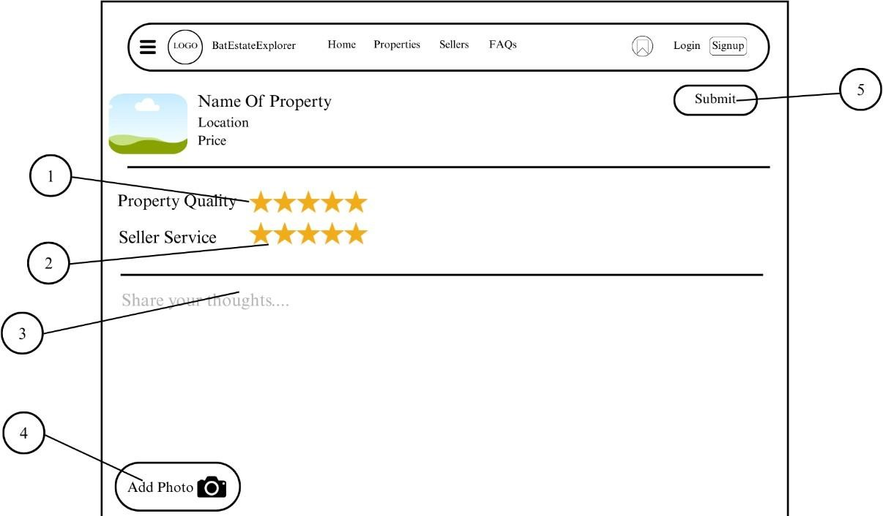

for feedback, Add Photo Button (4) to add a photo for documentation and a Submit Button (5) to upload the rating.

- Quality Star Rate

- Seller Service Star Rate

- Share Your Thoughts Textbox

- Add Photo Button

- Submit Button

Figure 50. Rate Seller Section Interface



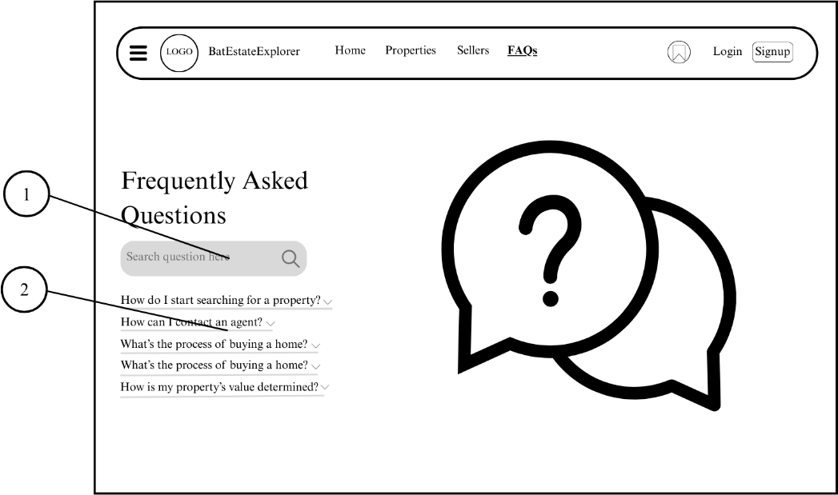

Figure 51 consists of a Search Button (1) to search questions and a FAQs Dropdown (2) that has an answer.

- Search Button
- FAQs Dropdown

Figure 51. FAQs Section Interface
Figure 52 shows the Saved List Properties. The Property Image Box (1) is a high-quality image of the property, Seller’s Profile (2) with his/her name and position, View Details Button (3) to view full details of the property, Message Seller Button (4) to message the seller, and Remove Button (5) to remove the property from the list.
- Property Image Box



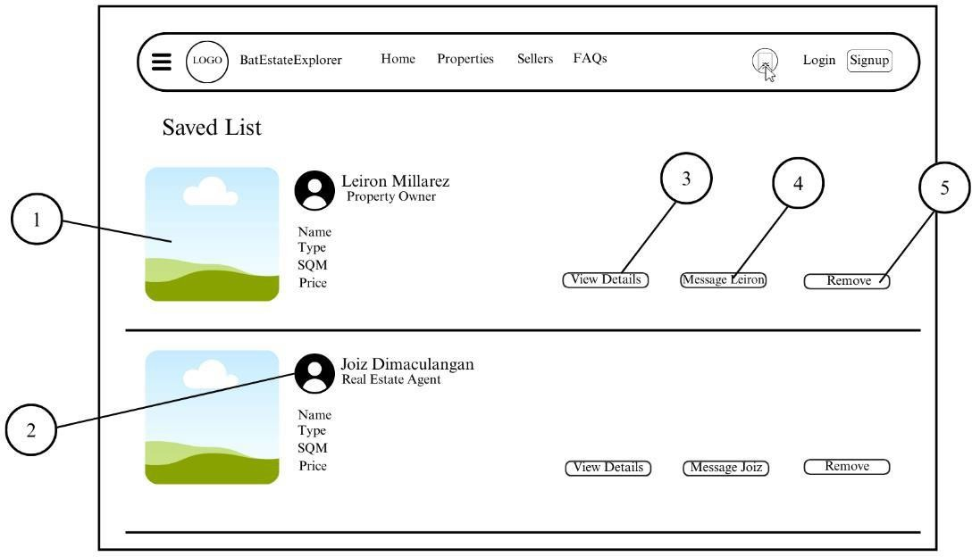

- Seller’s Profile

- View Details Button

- Message Seller Button

- Remove Button

Figure 52. Saved List Interface

Figure 53 shows the Menu Tab at the left side of the platform. It consists of User Account Dropdown (1), Edit Profile (2) and Delete Account (3), Inbox Button
(4) to open conversations, Sell Now! Button (5) to apply as property owner to sell properties, Log Out Button (6) to exit the platform.
- User Account Dropdown



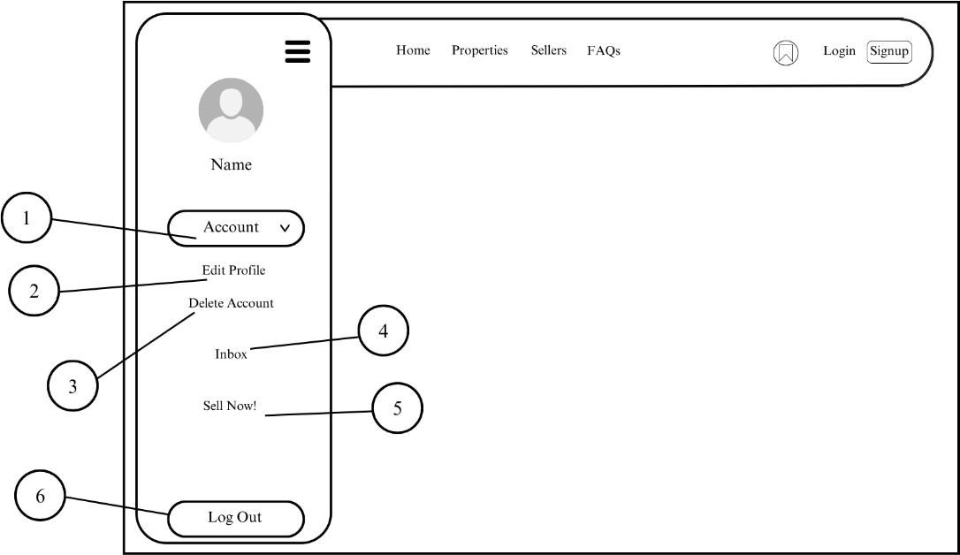

- Edit Profile Button

- Delete Account Button

- Inbox Button

- Sell Now Button

- Log Out Button

Figure 53. Menu Tab Interface

Figure 54 shows the Application Form if the User wants to sell a property. User must provide his/her personal information in the First Name Textbox (1), Last Name Textbox (2), Email Textbox (3), Phone Number Textbox (4), Select ID



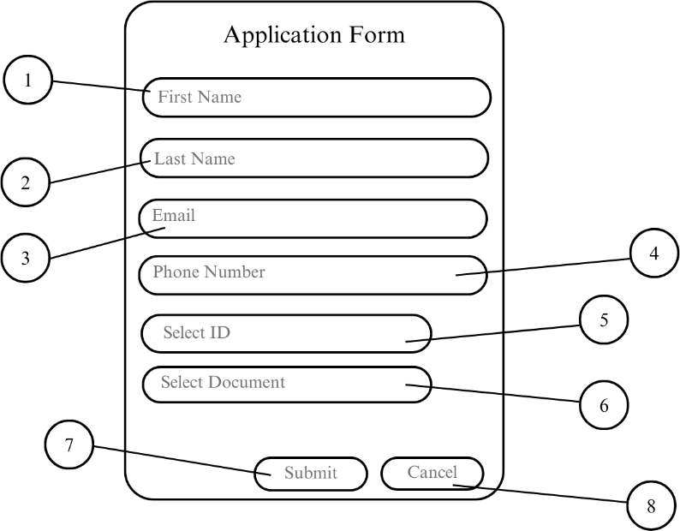

Button (5) to specify what kind of ID the user will provide, Select Document Button

(6) to specify what kind of Document the user will upload. Finally, a Submit Button
(7) to process by the administrators and Cancel Button (8) to cancel application.

- First Name Textbox

- Last Name Textbox

- Email Textbox

- Phone Number Textbox

- Select ID Button

- Select Document Button



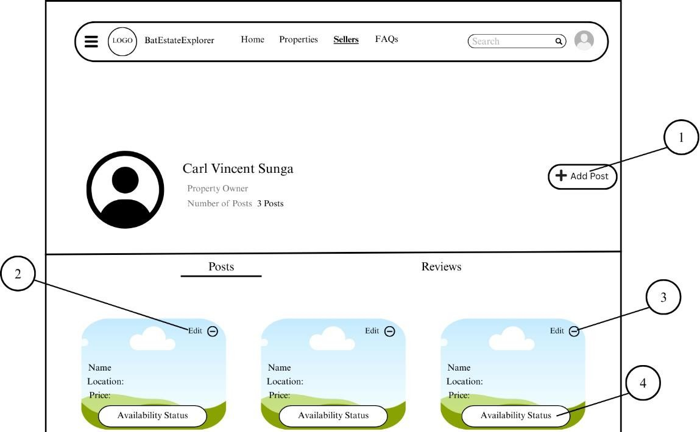

- Submit Button

- Cancel Button

Figure 54. Application Form (To Sell Properties)

Once the application is approved, the property owner can now upload a property. The interface is composed of Add Post Button (1), Edit Button (2), Delete Button (3) and Availability Status Button (4).

- Add Post Button

- Edit Button

- Delete Button



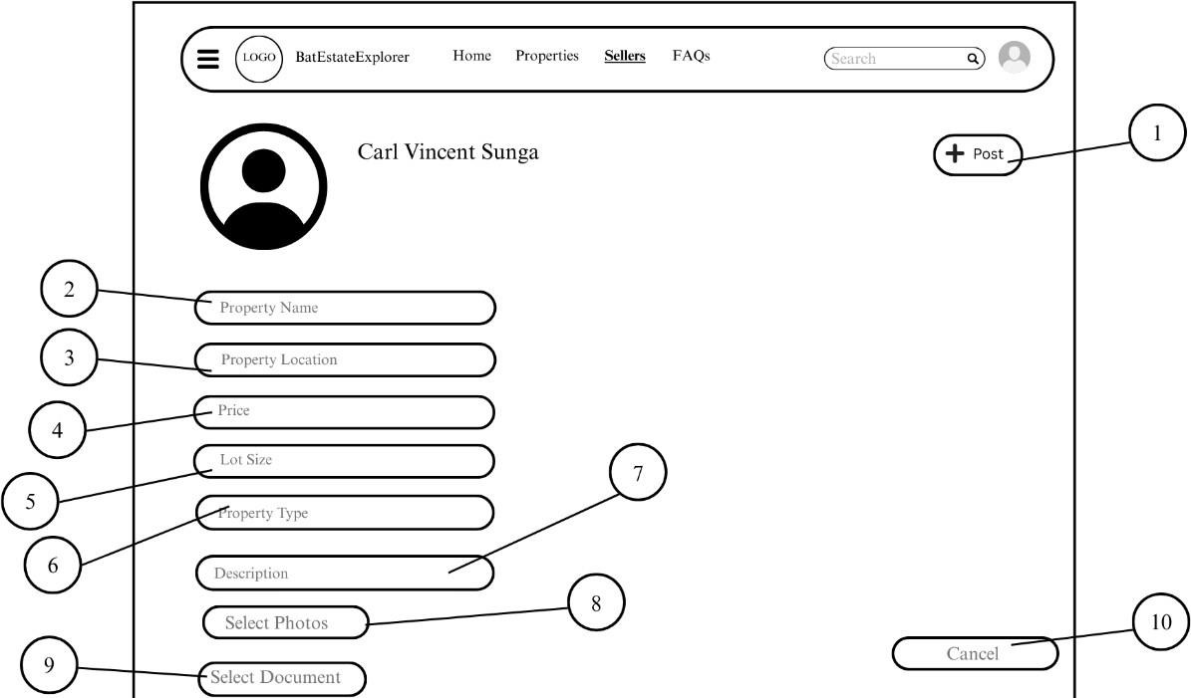

- Availability Status Button

Figure 55. Manage Property Listings Interface

Figure 56 shows the details when a seller is uploading a new property. It consists of Post Button (1) to post property, property details with Property Name Textbox (2), Property Location Textbox (3), Price Textbox (4), Lot Size Textbox (5), Property Type Textbox (6), Description Textbox (7), Select Photo Button (8) to select property image, Select Document Button (9) to select property’s document, and Cancel Button (10) to cancel upload.

- Post Button




- Property Name Textbox

- Property Location Textbox

- Price Textbox

- Lot Size Textbox

- Property Type Textbox

- Description Textbox

- Select Photos Button

- Select Document Button

- Cancel Button

Figure 56. Upload Post Interface (Property Owner)

Brilliant!!
So now, I am thinking of creating another type like the admin, but it is not an admin, it is a "Direct Agent" or a Seller, but prefer to be called Direct Agent. So this direct agent does not work from a company, just sellers who just want to sell properties as an individual.
So this Direct Agent should be able to
1. Log In and Sign Up, ( when the seller Signs Up, it will go to the admin's application list for it to be approved, if admin approves, then the account of the seller is created, if the admin declines the application of the seller, it deletes it. add some credential fill ups for the seller like brokers ID or something)
2. can also create/upload property listing including: (Details, images, etc. Any important details that are needed for a property listings should be presented),
3. allow seller to create portfolio that showcase their profile and listings
4. facilitating communication for potential buyers through inquiries (like there is a menu for messages for them to comunicate to buyers)
5. Give seller visibility of having analytics and reviews (this will show if the seller is good or bad like they have ratings on stars and grade like 1.0 being the lowest and 5.0 being the highest. As for the statistics, The agent should be able to see the status of his/her listings, but the direct agent is resposible to change the availablity of listing/property)
recreate the UI design interface in the image sent, and still keep consitstently what is in my css.
additionally, the Direct Agents should have a button on the index.html that says "become a Direct Agent". also for the login of the Direct agents is i don't know whhere to put it on the index.html though, give me suggestions if there is any. Thank you!
-----------------------------------------------------------------------------------------------------------------------------
Now, the purpose of the "Log In" and "Sign Up" button is for the Users
I want you to create a User Page now, let’s start with the User Profile Interface as it will serve as its home page as shown in the picture:
it contains:
- home button
- Properties button (which shows a page of properties with filter search function)
- Sellers button (which shows a page of sellers with search function and also has filters and sort by function
- note that you will recreate what is the design layout of the image given and also its design should match the colors and design of my website
as for the triple dots with a number 2 on it, it is supposed to have an option button to message or maybe even file a report that will go straight to the admin reports.
as for the number 1, it is like sections, refer to the design layout of others like in the admin_property_listings.html that I did.

